How To Use FCC Exam Questions Text Cleaner

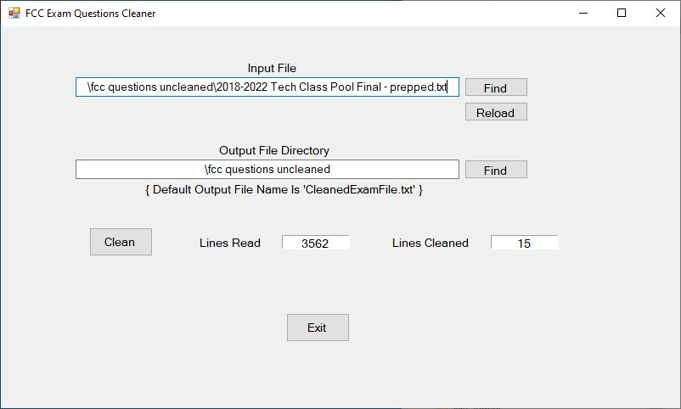

Preliminary cleaning

Before you run this program, you need to do a little manual editing. If you have not done so, export the source file into a plain text file (.txt). I usually add “ – edited.txt” to this initial version.

The editing consists of removing all the text down to the actual questions area. In the Technician pool document that is the line starting with, “FCC Exam Element 2 Question Pool…”. You also need to remove any text and graphics after the last question. Save this edited file. Now make a copy and rename it with “ – prepped”. This will be the working copy.

Load the text file

Near the upper right is the “Find” button. Click it and browse your way to the text file with the pool questions. If you followed my naming convention, it’ll be the one ending in “ – prepped”. Below that is the “Reload” button. If you edit the file manually you will need to reload it as the cleaner does not know you changed things. The program will keep track of the document location if you close the program and reopen it.

Running the program

Running the cleaner is simply loading the text file and then clicking the “Clean” button. There are two progress labels with the total lines scanned and how many clean-ups occurred.

Check the results

After running the cleaner, open the output file - CleanedExamFile.txt. Scan through the file looking for obvious issues. Sometimes you’ll find mystery characters usually denoted with a small square box in the text. If it seems to be an obvious character like a single or double quote then go ahead and change it. Otherwise just delete it. Once you are sure the document is ready you’ll run it through the parser. The parser will tell you if there’s still something wrong with the text.

Before you run it in the parser program, copy the name of the prepped file, then delete the prepped file and rename the cleaned file as the old prepped file. You’re ready for the next step.

# # #